|  |  |  |  |  |
| --- | --- | --- | --- | --- |
| **EMB00004e70326a** | | **Data Convergence ∙Consumer Research Expert**  **ConsumerInsight Report** | | |
| Company | ConsumerInsight | | E-mail | kimmh@consumerinsight.kr |
| Query | Kim, Minhwa Director | | Contact | 02) 6004-7643 |
| Issued | Thursday, May. 9th 2024 | | Pages | Total of 6 pages |

|  |  |  |
| --- | --- | --- |
|  | **Satisfaction of Koreans traveling to Japan, ranked:  1. Sapporo 2. Kyoto 3. Okinawa ConsumerInsight compares regional satisfaction for traveling Japan in 2023** |  |
|  | **- There are several popular destinations in Japan, and the willingness to revisit is the highest in the world**  **- The top three Japanese destinations account for 73% of the market share,  in contrast to Korea where 82% is concentrated in Seoul**  **- The satisfaction levels for Osaka and Fukuoka, popular among Koreans, are ranked the lowest**  **- There are also many hidden highly satisfying destinations such as Takamatsu and Kagoshima**  **- In terms of cost and satisfaction, Japan stands as a strong competitor to domestic travel destinations** |  |

○ In Japan, which has emerged as the favorite travel destination for Koreans, Sapporo (Hokkaido) was the location with the highest satisfaction. It was followed by Kyoto, Okinawa, and Tokyo in that order. Osaka and Fukuoka, despite being the most visited by Korean travelers, ranked below average in satisfaction.

□ The travel research firm, ConsumerInsight, conducts an annual study on satisfaction with overseas travel destinations every September. The firm surveyed 9,375 individuals who had traveled abroad between September 2022 and August 2023, asking about their satisfaction with their destinations and their likelihood of recommending those places to others. Among these, the firm analyzed responses from 2,302 travelers who visited Japan, comparing overall satisfaction, the attractiveness of travel content, and the comfort level of travel infrastructure in major travel areas (cities) such as Tokyo, Kyoto, Sapporo, Osaka, Fukuoka, and Okinawa, focusing on regions with over 60 respondents.

**■ Sapporo is the only city with an overall satisfaction score exceeding 800 points.**

○ Sapporo had the highest overall satisfaction score among the destinations with 805 points out of 1000, followed by Kyoto (788 points), Okinawa (780 points), and Tokyo (778 points). These four locations exceeded the overall average score for Japan, which was 767 points **[Table 1]**. Osaka and Fukuoka, the most visited by Koreans with travel destination shares of 29% and 24% respectively, scored the lowest with 753 points each. Sapporo was the only location among the six to exceed 800 points, making it the clear leader. It ranked first in terms of travel infrastructure (environment) comfort level and second in the attractiveness of travel content (resources).

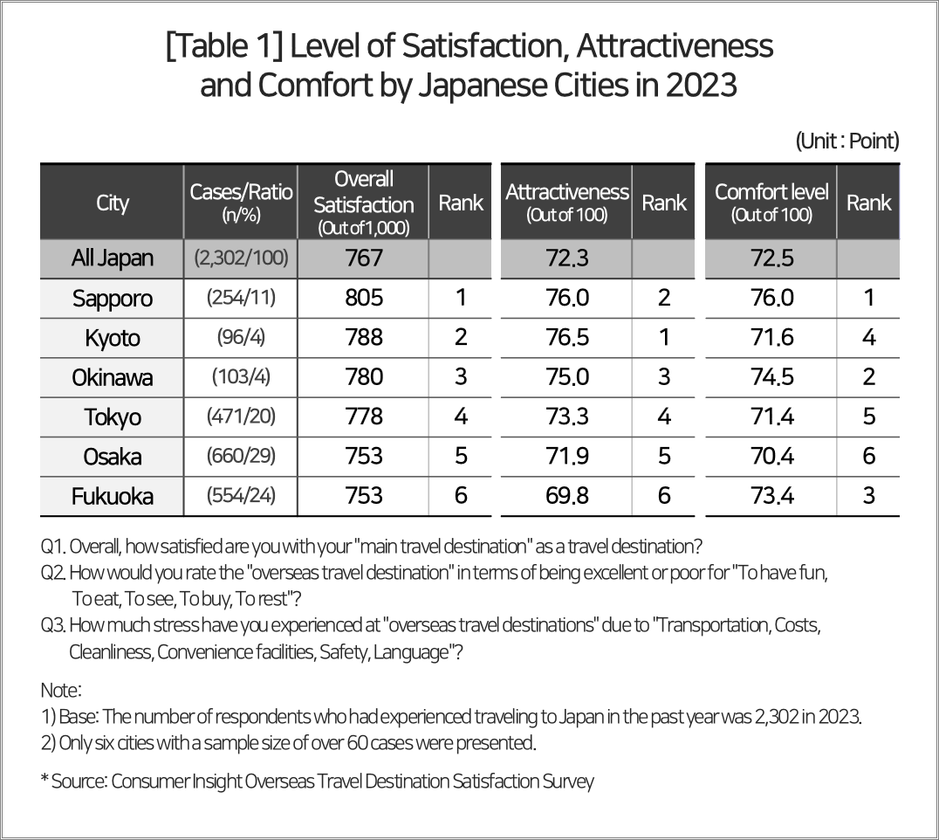

**■ Infrastructure comfort level division : Sapporo, Okinawa, and Fukuoka in order**

○ In the travel infrastructure comfort level division, encompassing Prices, Cleanliness, Convenience facilities, Safety, Culture/Language, and Transportation, Sapporo received the highest ratings across all six aspects, securing its position as the overall leader **[Table 2]**. Okinawa, which ranked second overall, tied with Sapporo for first place in the Culture/Language division. Aside from Transportation, where it ranked third, Okinawa secured second place in the remaining four divisions. Notably, the two islands at Japan's northernmost and southernmost points—Sapporo and Okinawa—dominated the top rankings.

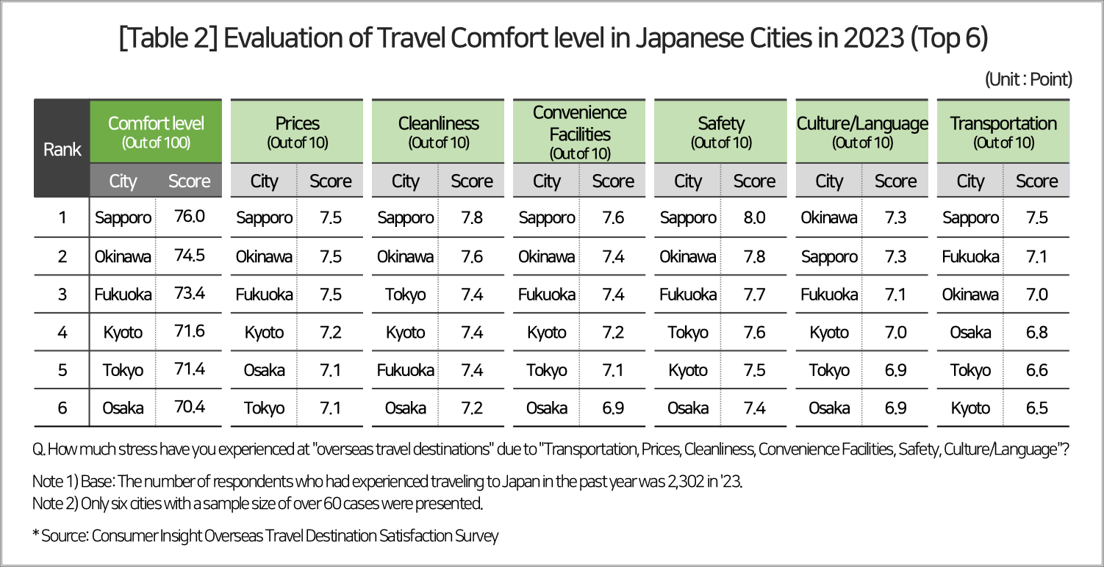

○ Kyoto (4th place), Tokyo (5th place), and Osaka (6th place) were commonly rated lower in the divisions of Transportation, Prices, and Safety. This appears to reflect their characteristics as major cities, where such issues are often more pronounced due to higher population density and the challenges that come with managing large urban centers.

**■ Attractiveness (Resource) division : Kyoto, Sapporo, Okinawa in order**

○ Kyoto ranked first overall in the attractiveness of travel content, evaluated across five aspects: To eat, To buy, To have fun, To see, and To rest. As a city with a rich historical tradition and urban characteristics, Kyoto scored the highest among the six regions in ‘To see’ and ‘To buy’ and was second highest in ‘To eat’ **[Table 3]**. Sapporo, ranking second, was noted for its ‘To see’ and ‘To rest’ options, reflecting its reputation as a resort destination famous for its snowy landscapes and hot springs.

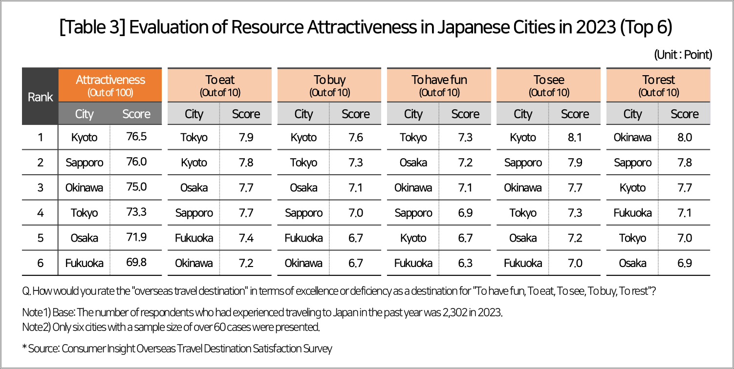

○ Okinawa ranked third overall, excelling in ‘To rest’ but receiving low ratings for ‘To eat’. Tokyo, in fourth place, ranked first in ‘To have fun’ and ‘To eat’, and second in ‘To buy’, but showed weakness in ‘To rest’ areas. Osaka and Fukuoka both experienced a general decline in rankings.

**■ Without diversifying its travel destinations, Korea may struggle to overcome Japan**

○ Japan has the advantage of having widely dispersed highly satisfactory travel destinations, from the northernmost Hokkaido (Sapporo) to the southernmost Okinawa. The proportion of Korean travelers by region is 29% in Osaka, 24% in Fukuoka, and 20% in Tokyo, totaling 73% for these three regions. Adding Sapporo (11%) brings the total to 84%. This is in stark contrast to the concentration of 82% of foreign travelers to Korea in one place, Seoul.

○ There were several lesser-known but noteworthy hidden regions in Japan. Among the places excluded from comparison due to a small sample size (less than 60), Takamatsu stood out with a comprehensive satisfaction score of 872 points, while Kagoshima also significantly surpassed Sapporo, the top scorer, with 853 points compared to Sapporo's 805 points.

○ Japan offers Korean travelers the highest ‘cost-benefit ratio’ in the world (see reference: [Why are Korean travelers flocking to Japan?](https://www.consumerinsight.co.kr/leisure-travel/r_Newsview?no=3520&PageNo=1)), and it holds the top position globally with a revisit intention of 78%. It is the only overseas destination for Koreans that perfectly meets the necessary and sufficient conditions for multiple re-visits (more than twice), including efficiency in time, space, and economy, comfort level, diverse shopping options, and satisfying culinary experiences. It is establishing itself as an irreplaceable alternative to Korea’s domestic tourism.

|  |
| --- |
| ConsumerInsight provides **professional** and **scientific** **research** **services** across various industries such as **automotive**, **telecommunications**, **shopping/distribution**, **tourism**, and **finance**, utilizing a **large**-**scale** **online** **panel** that is **efficient** for **non-face-to-face** **surveys**. We enhance the value of data by integrating **panel research data** with **various big data** sources, focusing on applying it to various industries. Particularly, we recently launched the "**KD-Panel**," a survey platform with a **100% mobile-based** approach and **nationwide representativeness**, which is **open for use by anyone in the research industry**. |

This report is based on the "Annual Overseas Travel and Travel Product Satisfaction Survey," conducted by the ConsumerInsight Consumer Trends Research Institute, which targets over 25,000 travel consumers every September. The survey results and analysis reports, updated annually, can be viewed at [www.consumerinsight.kr/eleisure-travel](https://www.consumerinsight.co.kr/eleisure-travel/), where summaries of the survey results from 2016 to 2022 are also available for download. ([Download Report](https://www.consumerinsight.co.kr/eleisure-travel/r_report))

---------------------------------------------------------------------------------------------------------------------

Copyright ⓒ ConsumerInsight. All rights reserved. The copyright of this material belongs to ConsumerInsight, and it cannot be used for commercial purposes other than reporting.

|  |  |  |
| --- | --- | --- |
| **For-more-Information** | | |
| Kim, Minhwa Research Director/Ph.D | kimmh@consumerinsight.kr | 02)6004-7643 |
| Lee, Jesung Chief Researcher/Ph.D | leejs@consumerinsight.kr | 02)6004-7631 |